Beer Name: Blackberry Porter
Brew Date: Jan 28’17
Batch Size: 10 gal
Target OG/◦ 1.067
Amnt lb/kg Ingredient

20 # Pale
2 # Dark Munich
1 # Chocolate
1 # Black Patent
1 # Flaked barley
1.5 # Wheat Malt
2 tabs irish moss

Qt oz/g Hop/Seasoning Time
56 g NB 90min
56 g Cascade 10 min
56 g Cascade 1 min
10 # Blackberrries ( frozen)
Stage Date
Primary: Jan 28’17
Racked: Feb 3’17
Racked:
Bottled: Mar 10 ‘17 6x1l
Kegged: Mar 10’17 1x 10 gal (leaked)
Re-Kegged: Apr 16’17
Purged: Charged:

Start Time: 7am
Fill mash tun: fri
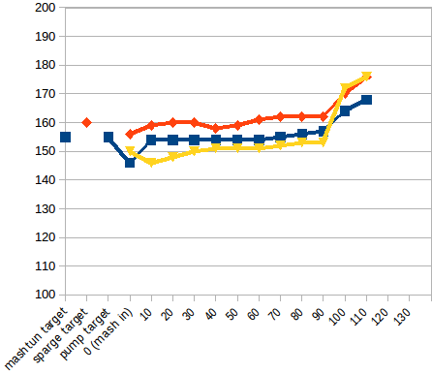
Fill sparge kettle: fri
Fire burners: 7am
Heat Mash Tun : Target Temp: 155
Heat Sparge Kettle: Target Temp: 160
Target Temp (Mash): 154
Grind grain: 8:05am
sparge temp: 156
Strike Temp: 156
pump temp: 156
Temp: 146
Mash: Duration: 90 minutes
Start: 8:15 Finish: 9:45am
Heat (to deactivate enzymes)
Target Temp: 168
Start: 9:45am
Finish:10am
Heat Sparge H20 (Target175◦)
Sparge:
Start: 10:13am
Finish: 10:55am
Wort collected: full kettle
Boil : Burner On: 10:15 or so
Rolling Boil: 11:07
Hops In: 11:25
Hops In: 12:45
Hops In: 12:54
Duration: 90 min
Start: 11:25
Finish: 12:55 pm
Burner Off: 12:55 pm
Rest 15 min
Start: 1:10
Finish: 1:35pm
OG : 1.068
Yeast: Nottingham Yeast
Irish Moss-no
Notes:
can’t get all the wort out of kettle without the special fitting

